Report on the lecture: Aspects of CEDAW delivered by Dr. Dipti Tamang, Fullbright-Nehru Post Doctoral Fellow Cornell University, 10-07-2021

CEDAW

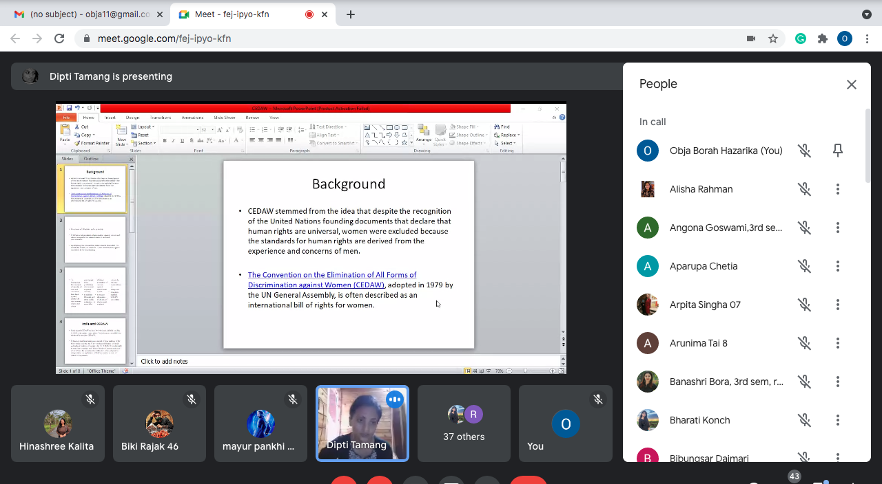

The idea of gender equality was being addressed in the UN and international policy making spaces-materialising in the form of gender mainstreaming. They were speaking about the importance of gender mainstreaming- which includes gender not as a separate matter in IR and questions on where and how do we incorporate gender equality at all levels.

So it was being discussed in various platforms regarding in what manner do we include gender equality and the question of gender mainstreaming- which is – the idea that states and actors and institutions- need a policy structure where gender equality is incorporated in policies and structures. In the backdrop of discussions around gender equality, we’ve witnessed the origins of policy frameworks such as the CEDAW- Convention against the elimination of all forms of discrimination against women in 1979.

Feminist advocates over the past few years have been skeptical of the idea of gender mainstreaming that all it did was ‘add’ some women in all levels and decision making bodies by emphasizing and ensuring the inclusion of women, presence of women and participation has contributed to participation but not true representation- ‘add women and stir’ approach; instead of actually ensuring access to power by women and ensuring that other goals of gender equality are achieved.

However, the CEDAW by encouraging that more women representation should be there in all levels, especially at the international level, did bring about a change as it was always noted that there were not enough women in IR which as a field is very male dominated.

However, at the policy structure level, the impression was that CEDAW simply ensured that more women participated – by there being more women on boards, but that did not ensure that women had access to power.

SO simply put- more women were included at many levels but that did not mean that gender equality was achieved.

CEDAW is seen as the bible by many fighting for gender equality and is a very important policy guideline- it is celebrated as including gender equality as a policy guideline in state policies and actions. CEDAW meant that the UN and other international spaces had broadened HR to include women’ and questions of gender into the policy making spaces.

So CEDAW was passed by the UN general Assembly – it was passed within the western, liberal framework- and stressed what steps can be taken to end gender based discrimination.

CEDAW provided a specific universal idea of what is defined as gendered discrimination, what steps states have to take to prevent discrimination and what states can do to end discrimination based on gender.

CEDAW provides an important policy guideline that emphasizes on the question of ending all forms of gender based discrimination. It addresses need to ensure equality of men and women in the legal system which meant that all discriminatory laws were to be abolished and legal mechanism was to be adopted that ensured that women can access and are entitled to certain rights which addressed the problem of oppressions which women may be facing because of their gender. So a legal system was to be developed by the signatory states to ensure equality based on legal mechanisms.

So, in UNGA guidelines, if a country signs and ratifies a treaty/convention then the country has to implement it in its domestic level. In regard to the CEDAW and other such conventions, a signatory state has to form a National Action Plan to implement the guidelines in the CEDAW and other conventions. Under this National Action Plan states need to show how they will be ensuring gender equality , the representation and participation of women in all levels of decision making, and if there are any obstacles which prevents gender equality from being reached, then the state needs to show what steps it is taking to remove structural inequalities. The National plans are roadmaps for the states in the direction of achieving these goals.

India and CEDAW

When it was signed in 1980 by India, it became the responsibility of India to implement it is its domestic sphere. UNGA resolutions are not binding on states. So, states which are signatories have the leeway in interpreting certain parts of such conventions. They cite that they are filing a reservation on certain portions of a treaty or convention – citing instances of it being in violation of their internal policy matters.

India also filed reservations on certain aspects of the CEDAW-providing room for India to not be obliged to implement the CEDAW in its entirety. .

India has expressed its reservations on article 5(a) – which was on issues of socio-cultural patterns and other was on Art 16(a) and Art 16 (b) – on the right to enter into marriage and right o choice of spouse, and article 29 (1) which is related to UN Security council resolution 13 (25) [UNSCR 13(25)].

The UNSCR 13(25) was celebrated in feminist spaces as a landmark resolution as it upheld women’s security in violent and conflict spaces.

India however, denies the presence of conflict in its domestic sphere and therefore the explaining India’s stand on the UNSCR 13 25).

In its foreign policy, India extends support to countries which are implementing UNSCR 1325) but maintains that there is no violence inside India therefore the absence on the inside/t

The India government is often questioned, especially in regions where there is AFSPA, whether it is ensuring women’s safety in such violence and conflict ridden pockets, but the Indian state maintains that there is no such violence.

Vishakha Guidelines- existed prior to 2013. In 2013, the prevention of Sexual Harassment(Prevention, Prohibition and Redressal) Act in the work place was passed. In 2012, the Indian government was in the spotlight after the rape case in Delhi. It was questioned that India had signed the CEDAW but has failed to address the increasing levels of violence against women.The Justice Verma committee was formed and this Act was created which made it legally binding for every workplace to have a mechanism to implement this Act- i.e. forum to redress sexual harassment in the work place. Prior to 2013, no Act, there was only the Vishakha guidelines.

The Vishaka Guidelines emerged in the context of the brutal rape and sexual absue of – Bhanwari Devi- a social activist working at the grassroots level in Rajasthan. She was raped by five upper caste gujjar men to punish her for her fight against the social practice of child marriage. Vishaka along with four other organizations filed a petition was filed in the Supreme court.

The Vishaka guidelines put into place – a mechanism to address sexual harassment in their work place.
The Vishakha guidelines in the absence of a precedent drew largely from the CEDAW- emphasizing on the commitment to address violence against women.

The fact that India had signed the CEDAW provided a base for the activists who wanted to push the govt. to form the guidelines or the Act.

If India had not signed the CEDAW, the activists would not have been able to draw from that to pressurize the govt to set up the guidelines or the Act. SO though the CEDAW is not mandatory, since India signed it, it could be held accountable by the activists and eventually policies and acts have been passed to promote gender equality.

Without those frameworks to address Sexual harassment a lot of steps such as GSCASH- which was the grievance redressal cell that was there in JNU based on the Vishakha guidelines, before the 2013 ACT , would not have been there. Now every work place has to have an Internal Complaints Committee for addressing matters of sexual harassment in the work place. So such frameworks like the CEDAW may be not binding but they act as policy guidelines which is something that can be used to make states accountable.

Currently, the question of violence against women in private and public spaces is being brought to the fore. India, due to the reservations which it had filed, can say that it does not interfere in matters of the private sphere as that would go against the countries’ socio-cultural ethos- but that leaves room open for violence against women.

Everyday India reports violence against women, especially dalit, tribal women but now the positive thing is that many women are speaking up about violence in the public. Conversations are taking place in the larger sphere, even in the mainstream media.

CEDAW introduced gender mainstreaming, and now transnational feminist advocacy groups have expanded widely. The new emphasis is on the Indian state to make a women peace and security action plan which stresses on the state needing to address the violence on women arising from the AFSPA but Indian state continues to refuse to acknowledge the existence of conflict in its domestic sphere. But the transnational scholars alliance is continually putting pressure on states to address the question violence against women and asks whether it is also a part of gender equality or not. They ask that UNSCR 13(25) be implemented by India and also whether gender equality should also be extended to sexual minorities and if mechanisms for the legal empowerment of sexual minorities should also be put in place as a part of India’s obligations as a signatory to the CEDAW.

