Prof. Surajit Borkotokey, Department on Mathematics, Dibrugarh University
‘Open Access Publishing, databases and research metrics’, 6.08.2021
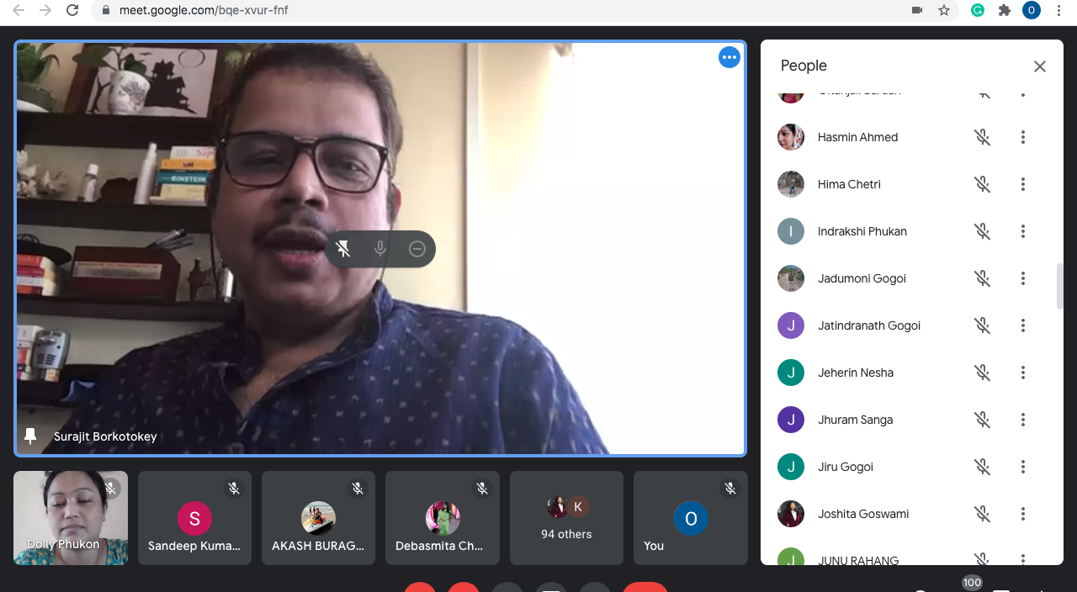
- Prof. Surajit Borkotokey, Department on Mathematics, Dibrugarh University talk on the topic ‘Open Access Publishing, databases and research metrics’, 6.08.2021
- Prof. Borkotokey gave a detailed presentation on the nuances of open access publishing and requirements of indexed journals.
- He also elucidated on the various databases and research metrics that are important considerations to gauge quality of nationally and internationally competent publication houses.
- Issues of subscription charges and predatory journals were also included in his presentation.

