Ms. Shabnam Yasmin and Ms Sampurna Baruah, Assistant Professors at the Centre for Applied Psychology, Dibrugarh University addressed the students of the Department of Political Science, Dibrugarh University on General Mental Health Awareness, on 26th November 2021.
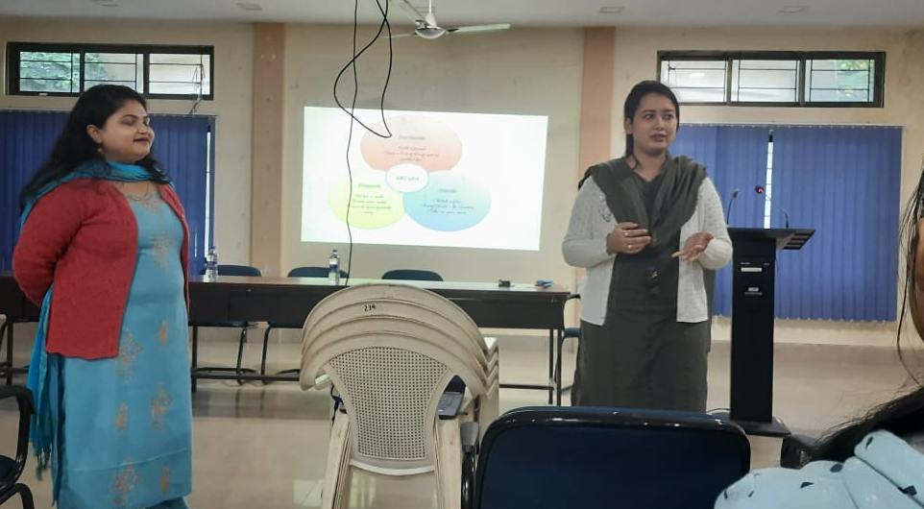
- They deliberated on the importance of awareness of mental health issues especially in the post- covid 19 times, given the new challenges of adjusting to an environment where anxiety and stress have been amplified due to the pandemic and associated social and economic problems generated by the disease.
- They spoke on the need to be aware of the intricacies and significance of mental health, to be able to understand them and take adequate measures on any issue.
- They also provided tips and techniques to the students and conducted exercises for mental health awareness during the interaction.
- Promotion of mental health and wellbeing is an integral part of Sustainable Development Goal 3 and universities can play a prominent role to help students address any such issues. Universities with such expertise are also well- positioned to help the local communties on addessing issues of mental health awareness

